Glenn Paley

Kelowna Volunteer Fire Department

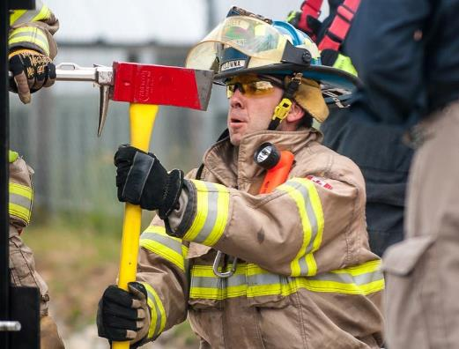
Glenn Paley has been in the fire service since 1993 when he joined the Kelowna Volunteer Fire Department. In 1998 he received a full time position as a career fire fighter. Prior to that he worked in the Civil Engineering profession. Glenn has been involved with training firefighters since 2006 and is currently the Training Officer/Safety Officer for the Kelowna Fire Department. He provides instruction and training scheduling for the Kelowna Fire Department to all of its members. Glenn also provides fire training to other departments and agencies throughout British Columbia including the Justice Institute of British Columbia. Providing training on dealing with Natural Gas and Electrical emergencies for the fire service is one of the many topics he is involved with and has worked hand in hand with Fortis BC to deliver this training.

