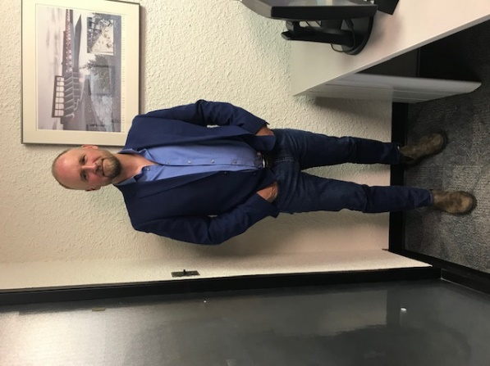
Robert Morrison

Damage Prevention Coordinator

Manitoba Hydro
Rob has worked for Manitoba Hydro for almost 30 years; starting his career in the “far North” as an apprentice in the line trades, slowly migrated south over the years. He currently acts as Manitoba Hydro’ Damage Prevention Coordinator and is responsible for minimizing risk and losses associated with damages to gas and electric infrastructure through the development and implementation of damage prevention programs, administrative measures and public and employee awareness education.
Prior to his role as Manitoba Hydro’s Damage Prevention Coordinator; Rob split his career spending the first half in overhead / underground field operations prior to moving into administrative and leadership roles. This included 4 years in employee relations and 7 years managing Manitoba Hydro’s Winnipeg’s Facility Locate Section which is where the “journey” starts for this presentation. Building a better line locate process; through automation, communication and resource management.

